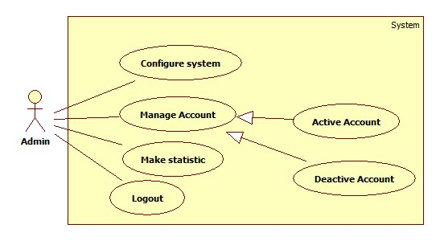

Manage account

Make statistic

Logout

Reference staff.

Configure system

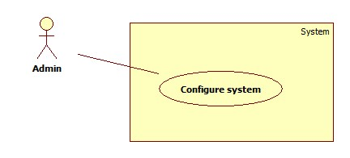

|  |  |  |  |
| --- | --- | --- | --- |
| **USE CASE – AU001** | | | |
| **Use Case No.** | AU001 | **Use Case Version** | 1.0 |
| **Use Case Name** | Configure | | |
| **Author** | Tran Le Tuan | | |
| **Date** | 15/01/2014 | **Priority** | Normal |
| **Actor:** Admin.  **Summary:**  Admin use this case to configure system.  **Goal:**  Allow admin to configure system.  **Triggers:**   * Admin want to configure system. * To configure: admin click on menu item “cấu hình hệ thống”.   **Preconditions:** admin must login system.  **Post Conditions:**   * **Success:** new configuration is applied to system. * **Fail:** System will show error on current page   **Main Success Scenario:**   |  |  |  | | --- | --- | --- | | Step | Actor Action | System Response | | 1 | Admin click on “Cấu hình hệ thống”. | System show configuration page. | | 2 | Admin input new value to configure system and click “xác nhận” button | System apply new configuration value and show message “Thiết lập thành công” |   **Alternative Scenario:** N/A  **Exceptions:** N/A  **Relationships:** N/A  **Business Rules:** N/A | | | |